Contact: Naomi Mabita - naomi.mabita@edf-feph.org
For immediate release
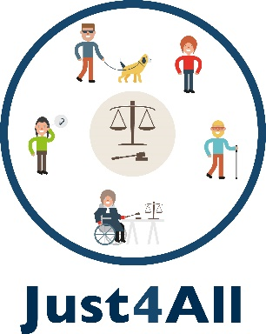

Working together to improve best access to Justice for People with Disabilities.

International webinar discusses the needs and the way forward to ensure more equal justice systems in Europe.

May 28th 2020 – The ONCE Foundation and its partners the European Association of Service Providers for Persons with Disabilities (EASPD), European Disability Forum (EDF), University Carlos III of Madrid and Thomson Reuters Aranzadi organized an international webinar to exchange and analyse the barriers and training needs of legal practitioners to ensure a full access to justice for persons with disabilities. The project is funded by the European Union’s Justice Programme (2014-2020).

In order to find solutions, public institutions, academic and legal organizations and disability platforms must work together. A European Code of conduct, protocols and training on disability and universal accessibility must be a mandatory for legal practitioners and for all other professionals involved in the justice system.

To advance in this direction, the project presented a Massive Online Open Course (MOOC) that will aim to contribute to this training, also incorporating examples of good practices, glossaries and related EU legislation.

The EU legal system recognizes this right in the European Charter of Fundamental Rights and in the UN Convention on the Rights of Persons with Disabilities, which specifies that "States Parties shall promote appropriate training for those working in the field of administration of justice, including police and prison staff" (article 13). We have to work together to make it effective.

You can find all the information at the website Just4All.eu.

Notes to editor
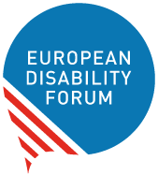
The European Disability Forum is an umbrella organisation of persons with disabilities that defends the interests of 80 million Europeans with disabilities. EDF is a unique platform which brings together representative organisations of persons with disabilities from across Europe. It is run by persons with disabilities and their families. EDF is a strong, united voice of persons with disabilities in Europe.

